**SBlood Oximeter Guide**

**With a simple and painless fingertip scan, our Advanced Blood Oximeter provides precise and reliable readings for key health indicators, including heart rate, oxygen saturation (spO2) levels, glucose levels, cholesterol levels, and uric acid levels. This all-in-one solution eliminates the inconvenience and discomfort associated with traditional blood tests, providing a non-invasive and hassle-free monitoring experience.**

**Designed with user convenience in mind, our Advanced Blood Oximeter is compact, lightweight, and incredibly easy to use. Its intuitive interface ensures that users of all ages can effortlessly track their cardiovascular health, respiratory well-being, glucose levels, lipid profile, and uric acid levels with unparalleled accuracy.**

**To enhance the monitoring experience even further, our blood oximeter can be seamlessly connected to your smartphone or tablet, enabling seamless data tracking and analysis. This connectivity allows you to gain valuable insights, identify trends, and share your progress with healthcare professionals for comprehensive and personalized care.**

Instructions:

1. The blood oximeter app is called MaxHeartReader  
   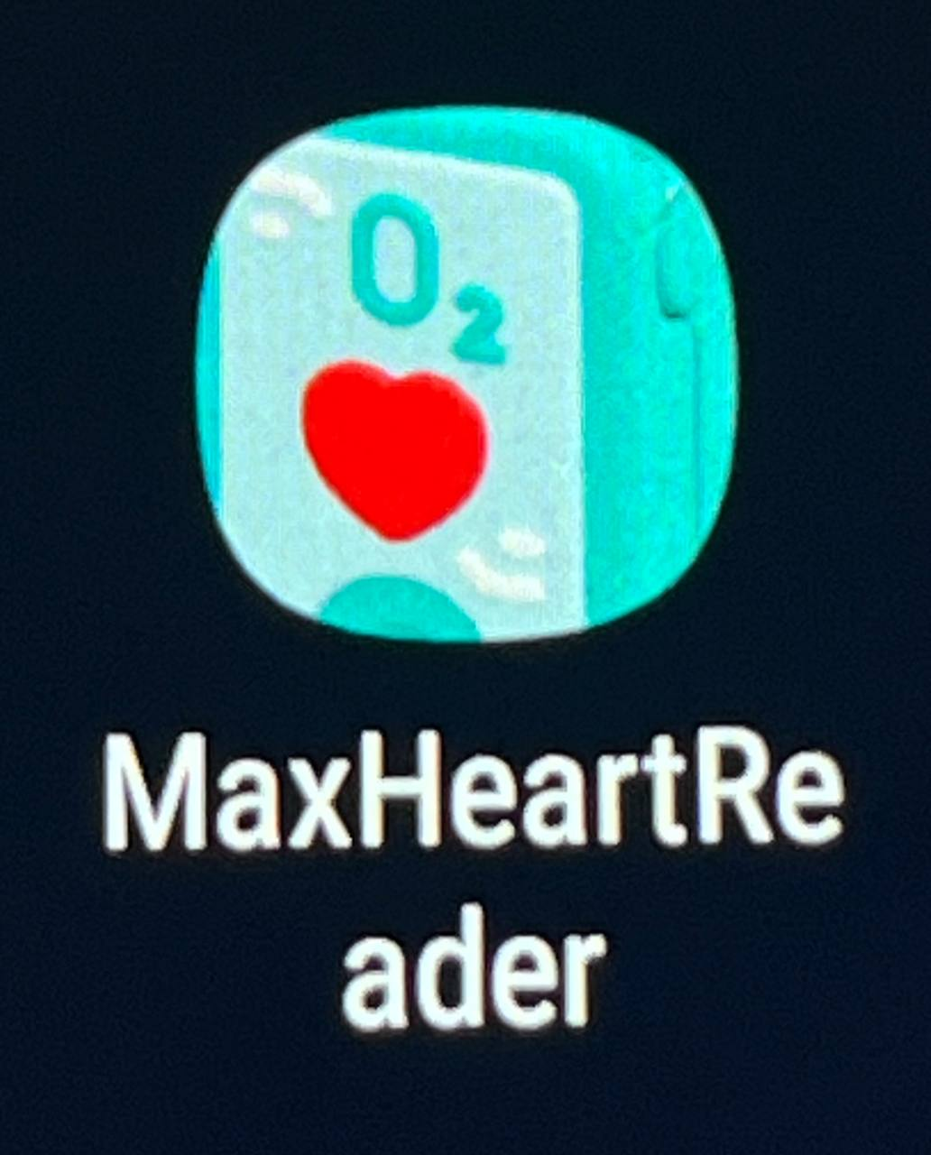
2. To retrieve locally stored csv or excel files:

My Files app > Internal Storage > Android > data > flutter_blueplus.trilogy_terchnologies_max_heart_r > files

1. To see the readings and the graph on the Find Devices page in the app, press the power button on the blood oximeter, and ensure that the oximeter is on and connected to the device.

Screen 1: Edit Profile Page

Here users can click on the input text box and type in the respective values and select their gender from 2 options, Male or Female.

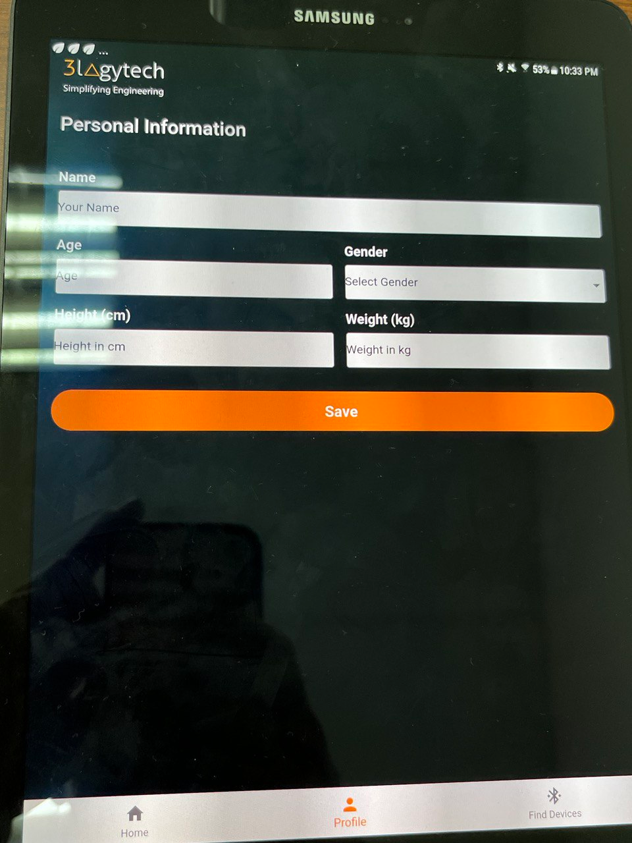

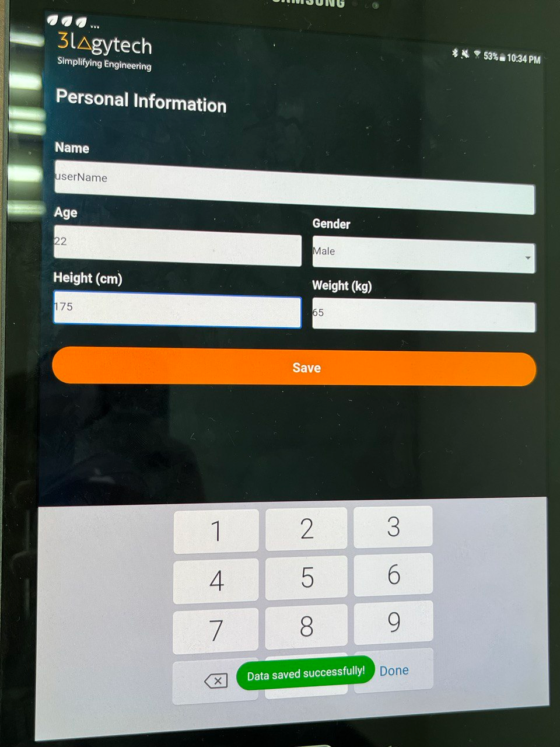

To save the data, they will click on the ‘Save’ button and the data will always appear there even after they have navigated to another tab. To change the input data, they just have to click on the box, retype in a new data and click on ‘Save’.

Screen 2: List of devices (Oximeter device connected)

When a device is connected, a row of data containing the variables that are being measured is displayed. They include heart rate, blood oxygen level, glucose level, cholesterol level, men uric acid level and women uric acid level.

Furthermore, a time series bar graph is plotted and shown below the readings. This following depicts the graph of glucose level in mmol/L (y-axis) against time (x-axis). The x-axis includes every data of readings which the user had taken, thereby enabling the medical professional to view the change in glucose levels over the entire day.

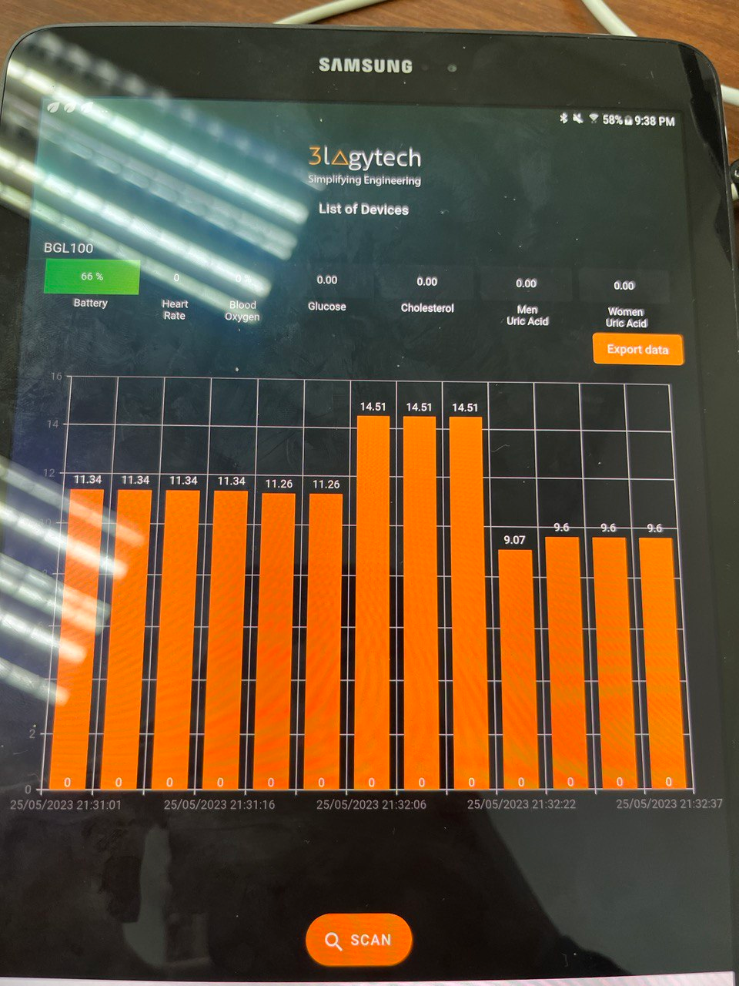

Screen 2.1: Export data

Data can be exported to different forms.

1. Exports the data and saves into the phone’s local storage as a CSV file or an Excel file format.
2. Emails the data in either as a CSV file or an Excel file. The file will also be saved into the phone’s local storage automatically.

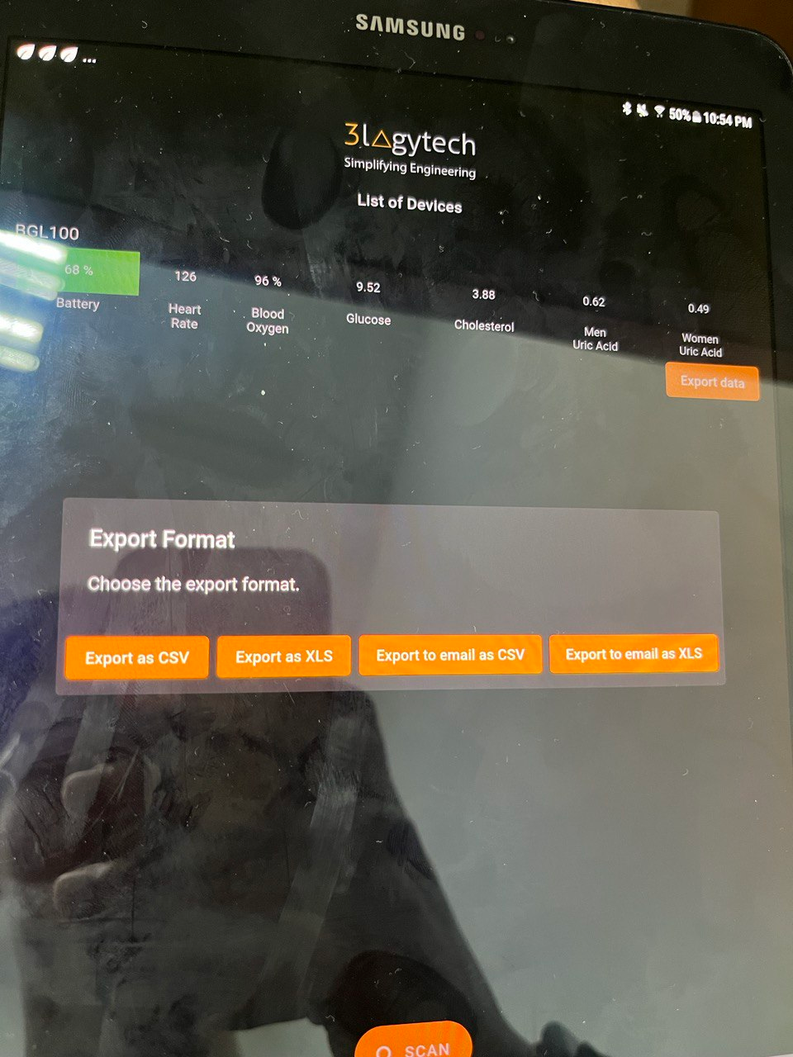

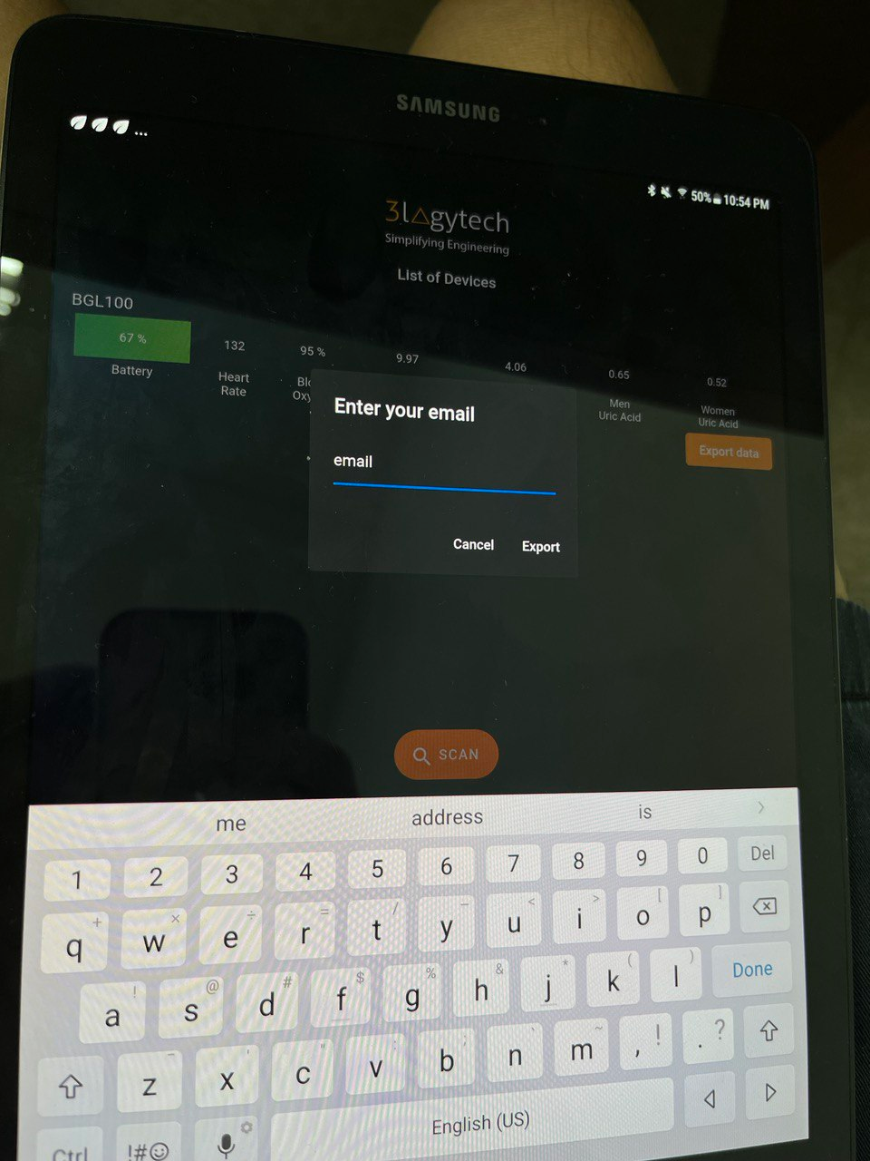

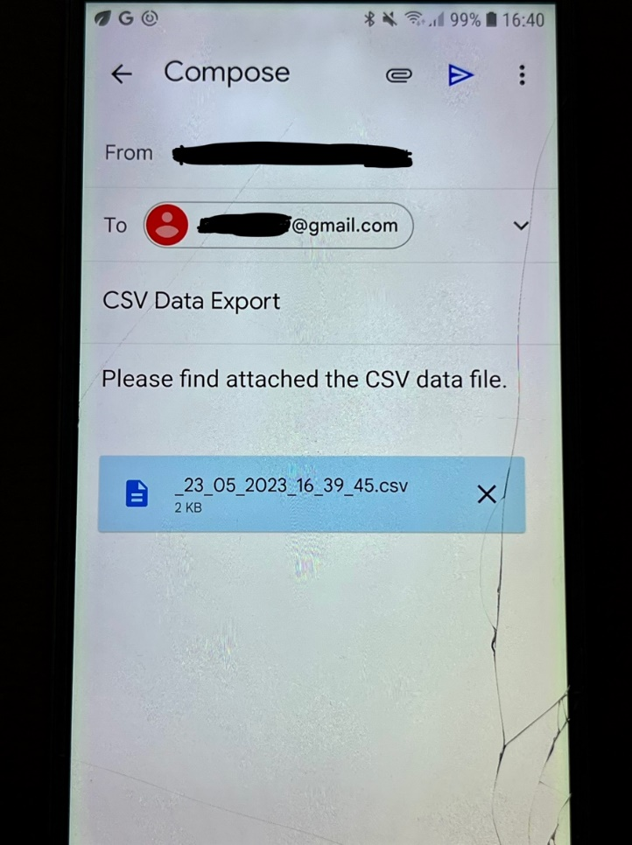

Here, the user will enter the email to send the data to.

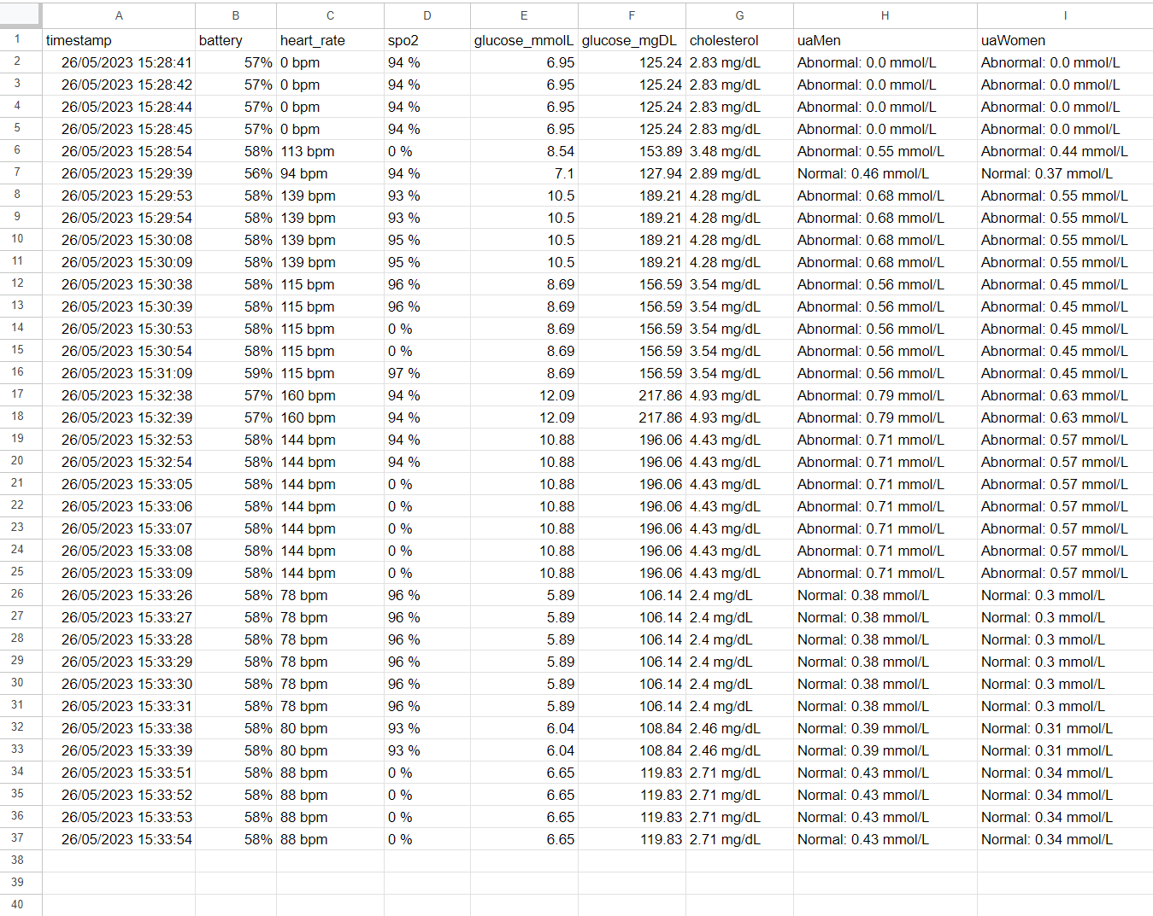

This is an example of the data that is being recorded. This is retrieved from the email account which the data was exported and emailed to.